- Planning scheme policy for Onsite Sewage Facilities (OSSF)

SC6.1.1 Objectives

The policy intent is for reticulated sewage to be provided during the subdivision and development of land. Where reticulated sewerage cannot be provided, the policy provides for on-site sewage disposal requirements.

SC6.1.2 Principles

- To generally require the connection of new subdivision and development to reticulated sewerage.

Reticulated sewerage provides the lowest risk to public health, environmental, social and economic, long term planning outcomes associated with sewage treatment and disposal.

  - Public health, amenity, water resources and environmental risks

Sewage may contain nutrients, metals, salts, endocrine (or hormone) disrupting chemicals, drugs, bacteria, viruses and other pathogens. If not adequately treated, these can affect water quality and result in water contamination and adverse impacts on public health and wildlife that rely upon the water for drinking or to support habitat.

  - Risks to long-term planning outcomes and land supply (reticulated sewerage supports the widest variety and changes of land use)

The provision of reticulated sewerage provides the most flexibility for land use planning and is fundamental to achieving the best use of existing and proposed infrastructure and protecting important environmental assets.

Onsite sewage facilities require land application areas for the disposal of treated sewage. This necessitates larger lots, resulting in low-density development and urban sprawl that requires the extension of other basic infrastructures such as potable water, electricity and gas. This is an inefficient use of both infrastructure and land.

In some areas that have had onsite sewage facilities, it has been necessary to retrofit reticulated sewerage to enable greater density of development and better environmental protection. The cost in this circumstance is generally borne by the greater community. The general requirement to connect to reticulated sewerage in the first instance aims to ensure such retrofitting programs are not needed in the future.

- Protection of public health and amenity

  - Impacts on public health

Illness arising from exposure to pathogens contained in sewage. Exposure can result from a variety of causes, including system malfunction, poor maintenance and natural disasters/extreme events. Illness can be low-level ongoing such as gastrointestinal complaints and respiratory conditions; or high-level, life-threatening such as encephalitis, and bacterial infections such as E.coli, salmonella or campylobacteriosis.

If sewage is discharged into waterways or the marine environment, diseases to humans can also be transmitted through eating sewage-contaminated shellfish or recreational activities, such as swimming.

  - Reduced amenity from sewage odour

This may affect people at a household level from onsite disposal systems, or at a street or community level, where people live or work in proximity to a wastewater treatment plant or other wastewater infrastructure. It may occur as a result of unfavourable site and soil conditions, poor system management and/or maintenance practices or uncommon events.

  - Reduced development potential of land

This applies where a land application area is required for onsite sewage disposal. The area needs to be set aside for distribution of the treated effluent and cannot be built over with any permanent fixtures, or used for children’s play areas or growing fruit and vegetables. The location may interfere with where a landowner may want a dwelling to be built due to the slope of the land. Undertaking activities such as laundry need to be considered as overloading of the land application area can result if too much water is used at one time. The risk of purchasers not being aware of these limitations is very real if notifications on the title are not placed at the time of subdivision.

- Protection of the environment, land and water resources

  - Contamination of land and/or buildings

This may occur from the direct discharge of untreated or partially treated sewage to land; through poor maintenance; or mechanical failure of plant and/ or equipment.

  - Contamination of groundwater

Resulting from rising groundwater or infiltration of rainfall through soils contaminated by untreated or treated wastewater discharge. This is particularly relevant to public health if the sewage discharge contaminates an aquifer used for drinking water supply. Detrimental impacts on the groundwater ecosystem (for example, stygofauna) may also result.

  - Contamination of surface water

Through direct discharge of treated or untreated wastewater from wastewater infrastructure to stormwater drains, waterways or wetlands; runoff passing over contaminated land; or discharge of contaminated groundwater to surface waters, including wetlands and estuaries. Diminishing the water quality of a surface water source may result in the loss of a resource. The quality of treated wastewater can also be too high in nutrients for the receiving environment, leading to eutrophication. Eutrophication of water bodies results in algal blooms, fish kills, and increased breeding of mosquitoes and midges. Other contaminants in sewage, including endocrine-disrupting compounds, have been observed to impact receiving ecosystems.

  - Impacts on health of flora/ fauna

From exposure to contaminated land and/ or groundwater or surface water (including fresh and marine water). Sewage discharged into waterways causes oxygen depletion which reduces the amount of oxygen available to fish and other aquatic animals and plants which can result in their death. As sewage also contains high levels of nutrients, it can elevate algal growth and bacteria..

  - Wasting of water resources

This occurs when treated wastewater is discharged into the environment without being beneficially reused. It is increasingly recognised that wastewater is an untapped resource. Total water cycle management is more easily implemented with centralised systems such as through sewer mining, aquifer recharge, watering for public open space and using the biosolids for energy generation.

- Efficient use of infrastructure and land

  - Low-density development results in a less efficient urban form

Where reticulated sewerage is not provided, larger lots are required to accommodate on-site sewage disposal systems and their associated land application areas. As part of the risk management process and to acknowledge that the land application system will not last the lifetime of a dwelling, AS/NZS 1547 recommends a reserve area be made available in the event of the land application area becoming unusable for its purpose (for example, through soil salinisation), which further impacts lot size.

  - Reduced flexibility to change or intensify land use in future

Where land is subdivided and developed without reticulated sewerage, the potential for increased density of development in the future is greatly reduced. Similarly, unsewered areas that may have originally been used for one land use, but have now been identified to transition to another (for example, light industrial to urban), are difficult to retrofit to enable reticulated sewerage.

  - Unsewered development undermines the provision of a reticulated sewer to a local area

This may occur through reduced viability of infrastructure extension due to the limited number of existing unsewered lots.

  - Reduced performance of treatment system from uncontrolled discharges

This is generally a result of the unauthorised discharge of trade waste but can also occur as a result of household chemicals being disposed of into sewage systems. This applies to both reticulated schemes as well as onsite systems, which are likely to require additional aspects to pre-treat waste (for example, oil separators) for non-domestic situations.

  - Restriction on type and intensification of land use

Future land uses, and/or intensification of land uses may be precluded through a lack of reticulated sewerage.

- Avoid costs to the broader community

        - Remediation of soil and/or surface waters and/ or groundwater

Long-term on-site sewage disposal in sensitive areas contaminates the soil profile, groundwater and receiving surface water bodies, such as rivers, wetlands, estuaries and embankments. At a local level, this may result from an on-site system failure, pipe breakages, or at a larger scale from discharges, or failure of larger infrastructure such as a pump station or wastewater treatment plant. Over time, all systems will leak and require replacement, however, this may not always be immediately evident and contamination of land and water occurs. Remediation of eutrophied water bodies is expensive and a cost borne by the broader community.

        - Retrofit of a failed treatment system

The magnitude of costs and works is largely reflective of the scale of the system. In some instances, the costs may be borne by the broader community, whereby the progressive conversion of unsewered areas has been undertaken.

        - Increased health costs

To the broader community as a result of these costs being subsidised with public funding. This is linked to illnesses arising from exposure to pathogens from sewage, both from reticulated and on-site systems and the treatment required to address/ remedy the effects.

        - Reduced employment opportunities

This may occur if low-cost industrial development is not supported through the release of appropriately zoned unsewered land. This generally occurs if there are businesses with few employees yet require large lots for the type of business activities undertaken.

        - Ongoing maintenance

Applies to both reticulated and on-site disposal systems but is more onerous for individual landowners as they have to inspect and ensure maintenance of a system themselves. Onsite systems are also resource-intensive for local governments as they are required to inspect and audit systems to ensure compliance with the conditions of their approval.

- Adopt the precautionary principle approach

When considering the above risks and the appropriate treatment and management of sewage, the precautionary principle reinforces the policy approach to requiring reticulated sewerage as the default position of the local government. The policy intent is for this principle to be applied in decision-making to protect public health and the receiving environments.

SC6.1.3 Purpose

The purpose of this planning scheme policy is to:-
- provide qualitative guidance for consultants to reduce the time and effort involved in the assessment process without compromising the protection of environmental values.

The policy provides advice and guidance on how to prepare the following OSSF plans:
- Site layout plan;
- Wastewater plan;
- Water risk assessment; and
- Reticulated sewerage feasibility assessment.

Note—the OSSF code and this planning scheme policy do not apply to sewage facilities that exceed 21 EP or 4,000L/day (in accordance with DES ERA EP guidelines). Those systems are an Environmentally Relevant Activity (ERA) under the Environmental Protection Regulation 2019 and require an application for an Environmental Authority through the Department of Environment and Science (DES).
Editor’s note – 1EP is equivalent to 200/L/p/day (in accordance with the DES ERA EP guidelines).
Note—nothing in this planning scheme policy limits Council’s ability to request other relevant information in accordance with the Act.
Note - the OSSF code and this planning scheme policy do not negate the need to seek approval of an OSSF under the Plumbing and Drainage Act. Before an OSSF can be installed on a property, the applicant is required to apply for a permit to install the treatment facility on that property. Applications to install an onsite sewage facility are to be lodged with Council as part of the plumbing/drainage application.

Application

This planning scheme policy assists with satisfying the assessment benchmarks in the Fraser Coast Planning Scheme that relate to OSSF for accepted development subject to requirements and assessable development as outlined in the table below:

Table 1: Application – OSSF plans
Section or table in the code | Assessment benchmark reference | Section in policy
Water resource catchments overlay code
Table 8.2.11.3.1 Assessment benchmarks for accepted development | Sewerage requirements | Water risk assessment –  SC6.1.9
Table 8.2.11.3.2 Assessment benchmarks for assessable development | Sewerage requirements | Water risk assessment –  SC6.1.9
Onsite sewage facility code
Table X.X.X.X.X – Assessment benchmarks for assessable development and requirements for accepted development subject to requirements – if for building works made assessable by the planning scheme or material change of use applications | Site layout and setbacks  AOX | Site layout plan –  SC6.1.7
 | Site layout and setbacks  POX | Wastewater report –  SC6.1.8
 | Environment and public health  POX | Water risk assessment –  SC6.1.9
 | Where development is above or adjoins a groundwater aquifer relied on for the supply of drinking water  POX | Water risk assessment –  SC1.1.9
 | Cumulative impacts  POX | Cumulative risk assessment –  SC6.1.9
Table X.X.X.X.X – Assessment benchmarks for assessable development – if for Reconfiguring a lot applications | Cumulative impacts  POX | Cumulative risk assessment –  SC6.1.9
Reconfiguring a lot code
Table 9.4.3.3.1 Assessment benchmarks for assessable development | Size and dimensions of lots  PO3 | Wastewater report –  SC6.1.8
 | Services and utilities  AOX | Reticulated Sewerage Feasibility Assessment –  SC6.1.10
 | Services and utilities  POX | Reticulated Sewerage Feasibility Assessment –  SC6.1.10

This policy may also apply when a plan is required as a condition of development approval.

SC6.1.5 Relevant standards and policy

Reference and source documents that are to be read and applied in conjunction with this policy sub-section are as follows:
- AS/NZS 1546.1:2008 - On-site domestic wastewater treatment units-septic tanks
- AS/NZS 1546.3:2017 - On-site domestic wastewater treatment units-secondary treatment systems
- AS/NZS 1547:2012 - On-site domestic wastewater management
- AS/NZS 3500.2:2003 - Sanitary Plumbing and Drainage
- Environmental Protection Act - and all subordinate legislation, in particular, the Environmental Protection (Waste Management) Regulation 2000 (Design Rules)
- National Construction Code Volume 3 – Plumbing Code of Australia
- Plumbing and Drainage Act 2018 (and associated Regulations)
- Queensland Plumbing and Wastewater Code

Editor's note—Council has specifically referred to AS/NZS 1547:2012 On-site domestic Wastewater management and is, for the purpose of this policy, the adopted standard to be read and applied in conjunction with this policy sub-section.

SC6.1.6 Legislation

Plumbing and Drainage Act 2018

SC6.1.7 OSSF Site Layout Plan

When is an OSSF site layout plan required

AOX of the OSSF code requires the applicant to undertake a site plan as part of a development application.

About OSSF site layout plans

The purpose of an OSSF site layout plan is to demonstrate development includes suitable and adequate areas to accommodate the OSSF, 100% reserve land application areas and areas to service the facility. Early planning of on-site sewage facility infrastructure is essential to ensuring that design, treatment selection and facility siting are undertaken in a manner that at a minimum maintains health, environment, and public amenity and preferably improves these performance objectives.

Documentation

The plan is to be documented in an A3 format either in hard copy or digital format.

Level of detail required

The level of detail required for the site layout plan is outlined in the section below and is the minimum requirement.

Note: In some circumstances, additional information may be required depending on site-specific conditions.

Study area

The study area is the entire property that is the subject of the development application. Consideration should also be given to potential impacts adjacent to the study area.

Consultant qualifications and experience

The appropriately qualified and experienced consultant responsible for the preparation of the site layout plan must demonstrate one of the following:
- Queensland Building Construction Commission (QBCC) Hydraulic design licence with ODWM or limited to ODWM; or
- QBCC Site Classifier licence with ODWM qualification; or
- Registered Professional Engineer Queensland (RPEQ) with ODWM qualification; or
- A person who holds a licence under the Queensland Building and Construction Commission Act 1991 under which the person is qualified to develop the solution.

Preparing a site layout plan

- General components

In general, all site layout plans should incorporate the following components:

- North point;
- Full property description (lot, plan and address details);
- Name and any applicable qualifications of the person who evaluated the site;
- Scale of 1:200 or 1:500;
- Lot boundaries and dimensions;
- Location of any existing or proposed of future community title and common property boundaries;
- Contours indicating natural ground fall;
- Roads;
- Location, height, density and type of vegetation both on the subject allotment and on adjoining land which may be affected by the installation of the proposed OSSF;
- On-site sewage facilities;
- Onsite sewage disposal areas;
- 100% reserve land application area (which is unable to be developed, to provide for future resting or replacement of the system);
- Area for servicing the facilities,
- Test boreholes/pits;
- Easements and covenant areas;
- Neighbouring property details where relevant, but not limited to – location of dwelling (bedrooms, living rooms, recreational areas), swimming pools, potable water tanks, vegetation b)
- Overlays:
- Flood hazard overlays
- Coastal protection overlay
- Biodiversity areas, waterways, & wetlands overlay

Further, additional information is required based on the type of application:

- Building work made assessable against the planning scheme applications (e.g. Dwelling houses, Dual occupancies and a Domestic outbuilding on a vacant lots)

- Location of any existing and proposed:
  - Buildings;
  - Building footings;
  - Structures (including (but not limited to), carports, sheds, gazebos, etc;
  - Other areas (including (but not limited to), recreation areas, entertainment areas, patios, clothesline areas, and swimming pools (in-ground and above ground);
  - In-ground potable water tanks (on site and surrounding);
  - Fences and retaining walls;
  - Driveways and vehicle manoeuvring areas;
  - Pedestrian paths and walkways (formal and informal);
  - Landscaped areas
  - Stormwater drains, surface drains, sanitary drains and roof water disposal;
  - Water supply bores
  - Stream order 1-4 water courses, lakes, ponds, unlined stormwater drainage channels, dams, wells, groundwater aquifers or other water sources (on site and surrounding);
  - Details and locations of any diversion measures to collect surface or migrating subsurface water
- Nominate setbacks from those specified above to the requirements specified in accordance with:-
- Queensland Plumbing and Wastewater Code;
- AS/NZS 1547:2012 – On-site domestic wastewater management;
- AS/NZ 1546.1:2008 On-site domestic wastewater treatment units – Part 1: Septic tanks;
- AS/NZS 1546.2:2008 On-site domestic wastewater treatment units Part 2: Waterless composting toilets; and
- AS/NZS 1546.3:2008 On-site domestic wastewater treatment units – Part 3: Aerated wastewater treatment systems.
- Details of any site modifications, for example benching, cutting and filling, and how these impacts on the proposed system; and
- Any other information relevant to undertaking an assessment of the OSSF (e.g. suitable and safe means of access for servicing the facility).

- Material change of use applications

- Location of any existing and proposed:
  - Buildings;
  - Building footings;
  - Structures (including (but not limited to) carports, sheds, gazebos, etc;
  - Other areas (including (but not limited to), recreation areas, entertainment areas, patios, clothesline areas and swimming pools (in-ground and above ground);
  - In-ground potable water tanks (on site and surrounding);
  - Fences and retaining walls;
  - Driveways and vehicle manoeuvring areas;
  - Pedestrian paths and walkways (formal and informal);
  - Landscaped areas;
  - Stormwater drains, surface drains, sanitary drains and roof water disposal;
  - Water supply bores
  - Stream order 1-4 water courses, lakes, ponds, unlined stormwater drainage channels, dams, wells, groundwater aquifers or other water sources (on site and surrounding);
  - Details and locations of any diversion measures to collect surface or migrating subsurface water
- Nominate setbacks from those specified above to the requirements specified in accordance with:-
- Queensland Plumbing and Wastewater Code;
- AS/NZS 1547:2012 – On-site domestic wastewater management;
- AS/NZ 1546.1:2008 On-site domestic wastewater treatment units – Part 1: Septic tanks;
- AS/NZS 1546.2:2008 On-site domestic wastewater treatment units Part 2: Waterless composting toilets; and
- AS/NZS 1546.3:2008 On-site domestic wastewater treatment units – Part 3: Aerated wastewater treatment systems.
- Details of any site modifications, for example benching, cutting and filling, and how these impacts on the proposed system; and
- Any other information relevant to undertaking an assessment of the OSSF (e.g. suitable and safe means of access for servicing the facility).

- Reconfiguring a lot applications

- Proposed subdivision boundaries;
- Location of any existing and adjoining:
- Buildings;
- Structures (including (but not limited to) carports, sheds, gazebos, etc);
- Other areas – entertainment areas, patios, clothesline areas, areas including and surrounding swimming pools (in-ground and above ground);
- In-ground potable water tanks (on-site and surrounding);
- Recreation areas;
- Landscaped areas;
- Water supply bores
- Stream order 1-4 water courses, lakes, ponds, unlined stormwater drainage channels, dams, wells, groundwater aquifers or other water sources (on site and surrounding);
- Location of any existing and proposed:
- Infrastructure:
  - Roads
  - Electricity
  - Telecommunications
  - Footpaths
  - Stormwater drainage
  - surface drains
  - sanitary drains
  - roof water
  - overland flow and inter-allotment drainage;
  - reticulated water
  - reticulated sewerage
  - proposed location of sanitary drains
  - Details and locations of any diversion measures to collect surface or migrating subsurface water
- Fences and retaining walls;
- Sufficient building envelopes on each lot to contain future buildings and structures:
Zone | Minimum rectangle or square contained within a lot (m)
Low density residential (LDR1) | 25 x 120
Rural residential | 25 x 120
District centre zone | Sufficient area to contain future use and OSSF
Local centre zone | Sufficient area to contain future use and OSSF
Neighbourhood centre zone | Sufficient area to contain future use and OSSF
Low impact industry | Sufficient area to contain future use and OSSF
Medium impact industry | Sufficient area to contain future use and OSSF
High impact industry | Sufficient area to contain future use and OSSF
Waterfront and marine industry | Sufficient area to contain future use and OSSF
Other | Sufficient area to contain future use and OSSF

- Easements and covenants (future sewerage connection, stormwater, environmental, etc);
- Nominate setbacks from those specified above to the requirements specified in accordance with:-
- Queensland Plumbing and Wastewater Code;
- AS/NZS 1547:2012 – On-site domestic wastewater management;
- AS/NZ 1546.1:2008 On-site domestic wastewater treatment units – Part 1: Septic tanks;
- AS/NZS 1546.2:2008 On-site domestic wastewater treatment units Part 2: Waterless composting toilets; and
- AS/NZS 1546.3:2008 On-site domestic wastewater treatment units – Part 3: Aerated wastewater treatment systems.
- Details of any site modifications, for example benching, cutting and filling, and how these impact on the proposed system; and
- Any other information relevant to undertaking an assessment of the OSSF (e.g. suitable and safe means of access for servicing the facility).

Example site plans

The following is an example of the typical information and level of detail required

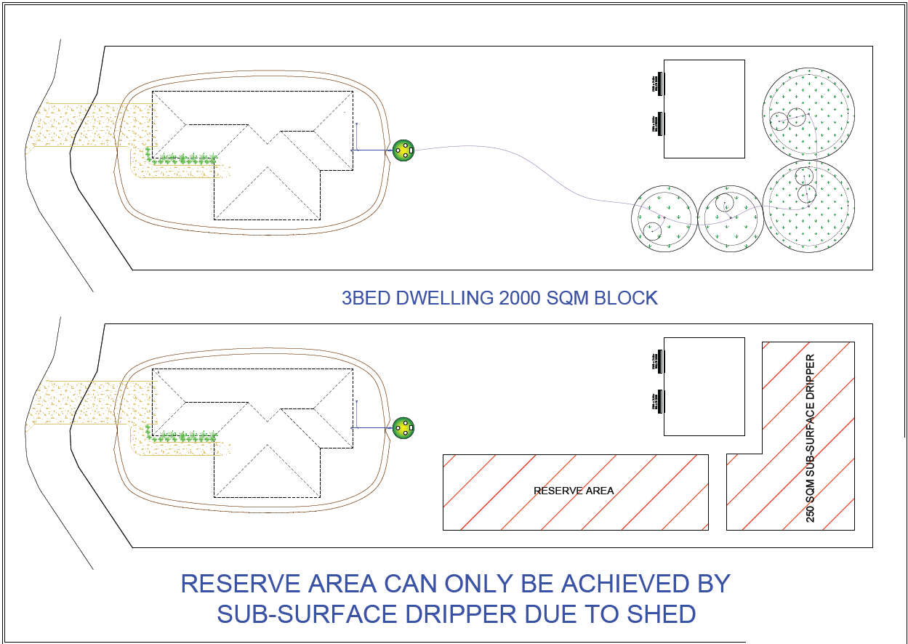
Figure 1 Example 1 - Dwelling House showing reserve area required

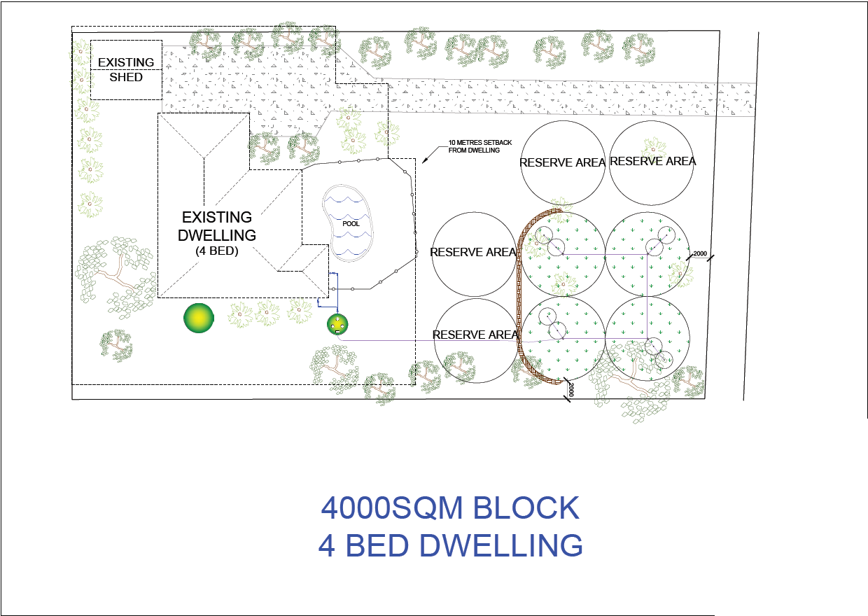
Figure 2 Example 2 - Dwelling house showing reserve areas required
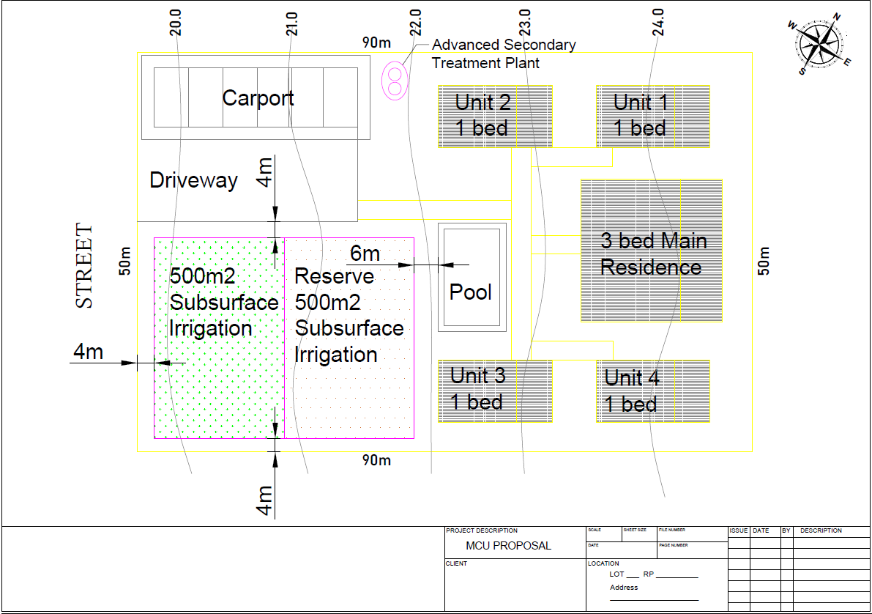
Figure 3 Example - Material Change of Use (Short term accommodation)
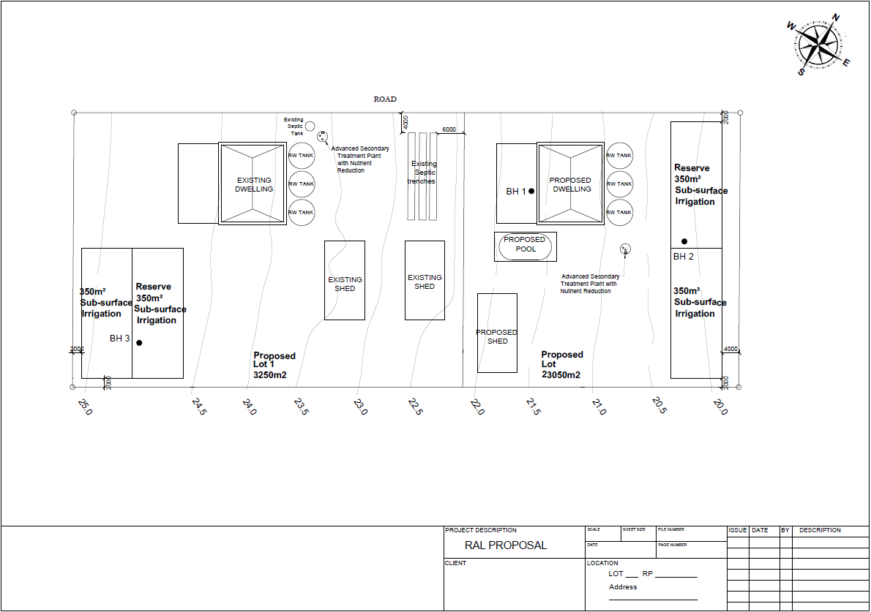
Figure 4 Example - Reconfiguring a Lot

Validity of site layout plan

Where a site layout plan is submitted and approved, the plan will remain valid the length of the currency period of the associated material change of use or building works made assessable by the planning scheme approval.

Level of detail

This policy outlines the key content which is common to most sites; however, additional information may be required in some circumstances depending on site specific conditions.

SC6.1.8 Undertaking a Wastewater report

When is a Wastewater report required

POX and POX of the onsite sewage facility code and PO3 of the reconfiguring a lot code requires the applicant to submit a Wastewater report as part of a development application.

About Wastewater reports

Wastewater reports are required to demonstrate the effective and safe treatment and disposal of onsite sewage, having regard to
  - the nature of the development proposed
  - demands the development will place on a system
  - the land and surrounding environment and
  - known hydro-geologic, public health or otherwise constrained concerns
  - seasonal changes in flow or water quality the system is to treat

Early planning of on-site sewage facility infrastructure (on-site sewage and effluent disposal facilities) is essential to ensuring that design, treatment selection and facility siting is undertaken in a manner that as a minimum maintains health, environment, and public amenity and preferably improves these performance objectives.

As development intensifies, the potential cumulative impact of on-site sewage facilities increases, and these objectives become more difficult to maintain for the environmental, public health and public amenity.

Documentation

The findings are to be documented in a written report in either hard copy or digital form.

Level of detail required

The level of detail required for a Wastewater report is outlined in the section below and is the minimum requirement.

Note: In some circumstances, additional information may be required depending on site specific conditions.

Study area

The study area is the entire property that is the subject of the development application. Consideration should also be given to potential impacts adjacent to the study area.

Consultant qualifications and experience

The consultant responsible for the preparation of the Wastewater report must demonstrate one of the following:
- Queensland Building Construction Commission (QBCC) Hydraulic design licence with ODWM or limited to ODWM; or
- QBCC Site Classifier licence with ODWM qualification; or
- Registered Professional Engineer Queensland (RPEQ) with ODWM qualification; or
- A person who holds a licence under the Queensland Building and Construction Commission Act 1991 under which the person is qualified to develop the solution.

Preparing a wastewater report

The Wastewater report shall include the following components:

- Site and Soil evaluation report;
- Design report
- Site Layout Plan

Where a Wastewater Report is required to be submitted as part of an application, the report should:

- provide sufficient information for deciding whether a development area, subdivision, or lot is suitable for onsite system(s);
- identify, analyse, and evaluate any risks posed by site-and-soil characteristics which might compromise the long-term effectiveness of the on-site system(s);
- identify, analyse, and evaluate any risks of contamination of groundwater or surface water and of associated health risks; and
- specify measures required to reduce and monitor such risks.

Note - There will be some situations where site and soil condition are so restrictive that on-site Wastewater land application becomes impracticable. In these circumstances it may be necessary to investigate alternative development outcomes and/or alternative onsite sewage treatment options.

- Site and soil evaluation report

All references are to AS/NZS1547:2012 –
- details of the site and soil evaluation personnel confirming:
- past experience of site and soil evaluation assessments;
- professional liability for the interpretation of, conclusions drawn from and recommendations made as a result of the site evaluation.
- desktop study as per relevant section of Appendix B2 of AS1547:2012
- site and soil check as per relevant section of Appendix B3 of AS1547:2012
- soil assessment items as per relevant section of Appendix B4 of AS1547:2012
- soil evaluation as per relevant section of Appendix C3 and Appendix D of AS1547:2012
- provide sufficient information for deciding whether a development area, subdivision, or lot is suitable for on-site system(s).

- Design report

All references are to AS/NZS1547:2012 –
- Details of the OSSF and land application facility designer confirming:
- past experience designing on-site sewage disposal facilities;
- knowledge of the regulatory design requirements; and
- professional liability for the interpretation of, conclusions drawn from and recommendations made as a result of the design.
- Documentation of the design process, including:
- system selection as per section 5.4 and 5.5 and Appendix J and K of AS1547:2012;
- soils and LTAR/DLR values as per section 5.5.5 of AS1547:2012; and
- design flows as per section 5.3 and Appendix H of AS1547:2012.
- Reserve area of 100% of the calculated land application area is provided for unless reticulated sewerage is planned by council to be connected in the area within 15 years of OSSF installation.
- Distribution system as per section 5.5.3.5 of AS1547:2012
- Nutrients as per section 5.5.6.1
- Rainfall surface flow control as per section 5.5
- Land use activity as per section 5.5.3.7, Appendix B3.1
- Groundwater table as per Appendix K and Appendix R of AS1547:2012

- Site Plan

As per section SC6.1.7 OSSF Site Layout Plan.

- Design

- Plumbing, drainage and installation of the complete on-site sewage facility must satisfy:
    - AS 3500.1:2021 Plumbing and drainage water services;
    - Queensland Plumbing and Drainage Act 2018;
    - Queensland Plumbing and Drainage Regulation 2019; and
- In order to develop an appropriate level of confidence in the results presented, the details, locations, and results of soil sampling and hydraulic property testing should accompany any report submitted.
- Any assessment that does not include this data collection and input carries with it an inherent risk of inaccurate prediction of effluent transport and behaviour and may even accentuate the utilisation of inappropriate system and disposal methods.
- The selection of the appropriate Wastewater treatment system and disposal method should be based on the individual characteristics of the lot in question and any reporting recommendations based on investigation (as outlined in this policy sub-section).
- The assumption of a single type of Wastewater system being utilised across all lots in any subdivision application is not recommended.
- Furthermore, it will be necessary for applications to demonstrate that there will be no adverse environmental impacts, taking into consideration cumulative impacts from other development, to place infrastructure near a watercourse, wetland, or open stormwater drainage channel/drain.

- Minimum Capacity

On-site Wastewater systems for each residential premises must be designed for a minimum capacity of six equivalent persons (EP) or 1,200L/day (in accordance with the DES ERA EP guidelines).

- MEDLI Modelling

Where an OSSF is proposed for a non-domestic circumstance (larger commercial and industrial developments and subdivisions), or when significant on and off season hydraulic loading is expected, appropriate effluent disposal modelling using MEDLI or equivalent is adopted using the hydraulic and mass (organic) design loading and resulting effluent quality in AS:NZS 1547. The modelling needs to include the design flows expected for the business, including future growth.

Note—the OSSF code and this planning scheme policy do not apply to sewage facilities that exceed 21 EP or 4,000L/day (in accordance with the DES ERA EP guidelines). Those systems are an Environmentally Relevant Activity (ERA) under the Environmental Protection Regulation 2019 and require an application for an Environmental Authority through the Department of Environment and Science (DES).

Validity of Wastewater report

Where a Wastewater report is submitted and approved, the plan will remain valid the length of the currency period of the associated reconfiguring a lot, material change of use or building works made assessable by the planning scheme approval.

Level of detail

A Wastewater report should demonstrate:
- sufficient information for deciding whether the proposed development and associated lot, are suitable for on-site system(s);
- identify, analyse, and evaluate any risks posed by site-and-soil characteristics which might compromise the long-term effectiveness of the on-site system(s);
- identify, analyse, and evaluate any risks of contamination of groundwater or surface water and of associated health risks; and
- specify measures required to reduce risk to an acceptable or tolerable level; and
- monitor such risk.

This policy outlines the key content which is common to most sites; however, additional information may be required in some circumstances depending on site specific conditions.

Deemed compliance – 3,000m² residential subdivision requirement

AO3.1 of the reconfiguring a lot code, requires a minimum 3,000m² lot size where on an unsewered lot for residential purposes. 3,000m² is the minimum lot size as it is deemed to provide adequate space for:
- building envelope;
- application area;
- reserve application area; and
- adequate setbacks (e.g. to waterways, structures, buildings, access, etc).

PO3 of the reconfiguring a lot code, requires an applicant to demonstrate, where not serviced by reticulated sewerage infrastructure, residential lots are of an adequate size to accommodate compliant OSSF and disposal areas to minimise risks to public health and the environment. To achieve compliance with PO3, an applicant would need to submit a Wastewater report complying with the planning scheme policy for OSSF, Wastewater report (SC1.1.6), demonstrating the proposed lots are an adequate size to accommodate the specific use, OSSF, disposal areas and setback requirements in accordance with the:
- Queensland Plumbing and Wastewater Code 2019; and
- AS1547:2012 (or more recent versions if revised).

The minimum lot size of 3,000 m² was selected as a generalisation for sub-division of what is achievable to ensure a building envelope, a land application area and a reserve area with appropriate buffers.

The calculation for OSSF infrastructure design incorporates the following;
- Soil type;
- Slope;
- EP (equivalent persons per dwelling) or L/day (in accordance with DES ERA EP guidelines); and
- Peaking factor to determine a design flow.

To determine a ‘nominal’ minimum lot size, a required land application area (LAA) for a large home on a restrictive soil type on a 4% slope was determined to back-calculate to a minimum total lot size.

A five bedroom house with a 6 occupant hydraulic loading on a soil category of medium to heavy clays was utilised to demonstrate a large home on a restrictive soil type.

Using tables and algorithms in AS1547:2012, this was calculated as a design loading rate of 2 mm/day and the land application area (LAA) using an ETA bed was calculated at 660 m².

In general, OSSF have a 15 year life span, as such, a reserve area of 100% of the design area (660 m²) must also be protected from development to enable future resting of the LAA.

This means that a minimum total of 1,320 m², not including setbacks, is required to service the on-site sewage system and future OSSF LAA for this lot.

The setbacks will differ depending on the lot shape and specific constraints. Table R1 from AS 1547:2012 provides guidelines for horizontal and vertical setback distances.

A nominal setback distance of 6 metres to a dwelling and 5 metres to a boundary on a 3,000 m² square shaped lot was used to calculate an example LAA, reserve area and setback to produce a ‘no build’ area of approximately 2,187 m².

This allows a remaining area of 812 m² for the five bedroom house (typical size 280 m²) and any additional setbacks required for primary street frontage (301 m² for a 5.5m setback along 54.8m), and recreational use.

While this is a ‘nominal’ size in a basic high-level ‘square’ scenario calculation, it demonstrates that a minimum 3,000 m² lot could be required for the appropriate servicing of an on-site sewage system, and that if smaller lot sizes are desired by the applicant, then an appropriate wastewater report demonstrating the lot specific use, setbacks and LAA sizing is required.

Similarly, if the lot shape is irregular or close to restrictive constraints such as neighbours and waterways the building envelope may not suit potential buyers and this should be considered.

The new lot needs the capacity to accommodate an onsite sewage facility, disposal area and reserve land application areas to service a 6EP system, but does not require an actual 6EP system be installed.

Indicative Land application areas for single house on different soil types

Table 1 below provides indicative land application area sizing for a hydraulic load of 1,000 L/day for varying soil textures.

Primary treatment or adsorption trenches may not be suitable to some locations, land use types or where groundwater is near to the surface.

Table 1 Indicative Land Application Area for a single dwelling house
Soil Cat | Soil texture | Land application area (m²)
Soil Cat | Soil texture | Primary treatment  (excludes setbacks) | Secondary treatment (excludes setbacks) | Secondary treatment (excludes setbacks)
 |  | Adsorption Trench | Adsorption Trench | Drip & Spray (Evapotranspiration)
1 | Gravels and sands | 48 | 24 | 240
2 | Sandy loams | 60 | 24 | 240
3 | Loams | 92 | 40 | 300
4 | Clay loams | 240 | 120 | 343
5 | Light clays | - | 150 | 400
6 | Medium to heavy clay | - | - | 600
Note: This table does not include setbacks or reserve land application areas, nor land application types and is provided for guidance only. Setbacks and land application area placement is specific to site constraints and changes with the shape of the LAA (even if the size is the same). Different sized areas may be required in response to hydraulic load or other variables.

SC6.1.9 Risk Assessment

When is a risk assessment required

POX and POX of the OSSF code requires the applicant to undertake a water risk assessment as part of a development application.

POX of the OSSF code requires the applicant to undertake a cumulative risk assessment as part of a development application.

About risk assessment

The purpose of a risk assessment is to demonstrate the impacts of the onsite sewage facility can be managed/mitigated to an acceptable or tolerable level.

Cumulative risks where development has a total daily capacity between 10 - 21 EP

Systems where the total daily capacity is between 10 – 21 EP or 2,000L - 4,000L/day (in accordance with the DES ERA EP guidelines) is below the trigger for an environmentally relevant activity (ERA), but this type of system is larger than a typical domestic system. Where not managed correctly, there is potential for negative cumulative health or environmental impacts, above those presented by a typical domestic OSSF on the same land area.

Examples of the typical type of development that generally requires a water risk assessment could include residential, commercial (e.g. offices) or industrial developments servicing between 10 – 21 EP (approximately 2,000L – 4,000L/day capacity in accordance with the DES ERA EP guidelines) in a non-sewered area.

When it comes to OSSFs of this size, the increase in cumulative risks is dependent on several factors, including but not limited to –

- an increased cumulative risk may be a lot of certain size being changed from domestic premises to a light commercial business where the daily hydraulic load increases from 1,000 L/day to 4,000L/day (in accordance with the DES ERA EP guidelines).
- the likely concentration of raw sewage or influent resulting from less dilution from domestic activities like showering. The hydraulic and mass load of organics from this type of development could mean a potential five-fold increase in the risk of sediment, pathogens, and nutrients entering waterways from the same land area.
- another increase in the risk profile could be the comparison in real-time monitoring of the system. Most domestic premises are personally invested in their OSSF system as poor operation results in immediate risks to them and their family.
- Larger residential, commercial and industrial of developments (residential, commercial an OSSF are likely to be operated and maintained by 3rd parties (e.g. a body corporate).

The cumulative risks have the potential to result in –
- General increase in environmental and health based risks;
- Increased hydraulic load on the same land area limits sustainable effluent disposal options (e.g. increased flow but a limited area to appropriately design);
- Increased organic and pathogen load increases the risk of runoff through poor design and/or operational practices;
- Increased sediment organic and/or pathogen load during storm events or prolonged rainfall;
- Over irrigation in prolonged rainfall leads to poor environmental outcomes and increased health risks;
- Lack of adequate operational controls results in overflows of treated or untreated effluent.
- Lower standard of treatment creates future Public Health and Environmental risk if subdivided; and
- OSSF intensity (e.g. hydraulic load per land area) increases (e.g. minimum two-fold), causing poor health and environmental outcomes.

Where development may impact groundwater sources and nearby surface water for potable purposes

Risks associated with OSSF impacting on groundwater and nearby surface water include:
- High pathogen loads that the drinking water treatment systems are not designed to remove;
- Pathogenic organisms not typically present in groundwater and resistant to typical groundwater treatment processes (e.g. protozoan pathogens that are chlorine resistant);
- Introduction of contaminants with health-based (and to a lesser extent aesthetic) water quality impacts e.g. high nitrate concentration; and
- emerging contaminants.

Determining appropriate nutrient levels in groundwater and nearby surface water sources is difficult to characterise and is site-specific, particularly on sites where external influences such as native fauna e.g. bird nesting sites, would have naturally occurring higher concentrations of nutrients and pathogens. Given it is difficult to characterise (without groundwater monitoring data) and even more difficult to appropriately predict (requires complex hydro-geochemical modelling), developments where onsite effluent disposal and groundwater and/or nearby surface water extraction for drinking purposes are proposed on the same site (or neighbouring sites) should adopt a precautionary and conservative approach.

Where development is above or adjoins a groundwater aquifer relied on for supply of drinking water

There are potential for serious public health risks associated where OSSFs are situated above shallow aquifers that are relied upon to supply drinking water. The actual health and environmental consequences onsite sewage facilities contaminating groundwater aquifers is highly complex and difficult to model and predict.

Fraser Island (K’gari) is one example of an area where it is common for development to be above or adjoin groundwater aquifers, which are relied on for the supply of drinking water. Given K’gari is a sand island, effluent disposal areas are likely to act as a slow sand filter, with sediment and undissolved nutrients filtered out by the sandy sub-soil. Resulting in dissolved nutrients and most pathogenic organisms reaching the groundwater table.

The anoxic groundwater environment (low to no dissolved oxygen) may not support the proliferation of pathogenic organisms, but immediate impacts on groundwater source for drinking include:
- High pathogen loads that the drinking water treatment systems are not designed to remove;
- Pathogenic organisms not typically present in groundwater and resistant to typical groundwater treatment processes (e.g. protozoan pathogens that are chlorine resistant); and
- Introduction of contaminants with health-based (and to a lesser extent aesthetic) water quality impacts e.g. high nitrate concentrations; and
- emerging contaminants

The EPP for K’gari does not include nutrients in EVs for groundwater. This is site-specific and difficult to characterise, particularly on sites where external influences such as native fauna e.g. bird nesting sites, would have naturally occurring higher concentrations of nutrients and pathogens.

Phosphorus can be taken up by the soil; however, this should not be relied on as a treatment or protection measure. Soil microbes may also undertake a degree of nitrification converting ammonia to oxidised forms of nitrogen (nitrate and nitrite). But beyond that nutrient reduction in sandy sub-soils such as K’gari are likely to be limited.

Given this is difficult to characterise (without groundwater monitoring data) and even more difficult to appropriately predict (would require complex hydro-geochemical modelling), developments on K’gari where effluent disposal and groundwater extraction for drinking purposes are proposed on the same site (or neighbouring sites) should ideally adopt a conservative position.

This is nominally proposed as secondary treatment with nutrient reduction as per AS 1546.3. This would require the OSSF to achieve total nitrogen limit of 15 mg/L and total phosphorus limit of 2 mg/L.

BOD and total suspended solids are less critical as these will be treated to some extent in the sub-soil (acting as a slow sand filter), however where groundwater is close to the surface, advanced secondary with nutrient reduction may be preferable.

Documentation

The findings are to be documented in a written report in either hard copy or digital form.

Level of detail required

The level of detail required for the particular risk assessment is outlined in the section below and is the minimum requirement.

Note: In some circumstances, additional information may be required depending on site specific conditions.

Study area

The study area is the entire property that is the subject of the development application. Consideration should also be given to potential impacts adjacent to the study area.

Consultant qualifications and experience

The consultant responsible for the preparation of the water risk assessment report is to be an appropriately qualified and experienced environmental engineer/scientist, civil or chemical process engineer with Wastewater design experience.

Preparing a water risk assessment

A risk assessment must satisfy the following requirements:

Cumulative water risk assessment - Where development has a total daily capacity between 10 – 21 EP or 2,000L – 4,000L/day (in accordance with DES ERA EP guidelines)

- The applicant should demonstrate that the OSSF has been designed, and will be installed and operated, such that health, environment and public amenity is at least maintained and preferably improved.

- In accordance with AS/NZS 1547:2012 On-site domestic wastewater management, demonstrate the proposed OSSF system is capable of adequately addressing the general “Performance Statements” (or objectives). Those statements at a high level are:
- To protect public health;
- To maintain and enhance the quality of the environment;
- To maintain and enhance community amenity; and
- To protect resources.

- Submit a wastewater report in accordance with SC6.1.8.

- Undertake a site inspection, site characterisation, soil testing and effluent disposal modelling, prescribed or recommended level of treatment demonstrating the site characteristics are considered against the risk.

- Treatment and disposal infrastructure is not placed in highly vulnerable areas where overland flow risks carry contaminants off site.

- An advanced treatment system or reticulated sewerage is utilised where it is established a high/extreme risk is associated with the proposed use.

- Include an effluent holding tanks for effluent storage.

Water risk assessment - Where development may impact groundwater sources and nearby surface water for potable purposes

- The risk assessment shall be conducted using the framework and methodologies included in ‘Drinking Water Quality Management Plan Guideline (DNRME, 2018)’ which aligns with the requirements of Australian Drinking Water Guidelines (ADWG).
The general methodology is as follows:
- Identify the hazards
- Determine the unmitigated risks
- Identify the preventative measures
- Determine the mitigated risks
- Classify the uncertainty associated with the assessment
- Identify verification or procedures used to ensure measures are effective
- Identify improvements for future implementation or consideration.

- The risk assessment should include (but not be limited to) identification and assessment of the following general hazards (provided as a starting point or guide):
  - Possible hazards and hazardous events associated with design and procurement for instance:
  - Non-compliant or non-compatible materials resulting in possible health or environmental impacts.
  - Access, ingress and egress risks (e.g. vermin and insects) from infrastructure such as storages, treatment vessels/reactors, disposal areas, etc.
  - Egress of contaminants resulting from design (e.g. leaks from tank penetrations below the normal liquid level).

- Possible hazards and hazardous events associated with construction or installation for instance:
  - Construction practices that result in irreparable or otherwise long-lasting damage to environmental aspects (e.g. erosion, soil instability, etc.).
  - Contamination of potable water supplies through any construction activities.
  - Potential for cross-contamination particularly where recycled water is in use.

- Possible hazards and hazardous events associated with commissioning such as contamination of groundwater and nearby surface water sources and/or excessive surface water runoff (erosion and soil stability).

- Possible hazards and hazardous events associated with the operational phase of the On-site sewage facility for instance:
  - Hazards resulting from complete system failure or failure of an individual component.
- Hazards resulting from failure to carry out regular maintenance.
- Hazards resulting from facilities or systems at or near end of life.
- Potential for cross-contamination or other hazards during change of land ownership or other future operational scenarios.

- The risk assessment should provide recommendations for necessary controls for the risk scenarios that are identified including the provision of potable water treatment systems (e.g. filtration, UV, etc.) for any risks that are assessed as ‘medium’ level or higher.

- Where the risk of an on-site sewage facility impacting groundwater and nearby surface water sourced for potable use is significant the design of Wastewater management infrastructure must include groundwater monitoring bores for future inspection and sampling as required.

Water risk assessment – where development is above or adjoins a groundwater aquifer relied on for supply of drinking water

      - An assessment of the likely groundwater conditions including where known or measurable: likely depth to water table, direction of groundwater flow, and groundwater quality with regard to sediment, nutrients and pathogens;
- an assessment of the risk to drinking water supply and treatment provisions to address these risks (e.g. UV treatment);
- a contoured general arrangement (site layout) of the development showing the on-site sewage facility, effluent storages (if applicable) and effluent disposal areas in relation to groundwater bores sourced for drinking water supply; and
- dimensioned overlays showing all requisite setbacks and separation distances from sensitive receptors.

- An assessment of the likely groundwater conditions including where known or measurable: likely depth to water table, direction of groundwater flow, and groundwater quality with regard to sediment, nutrients and pathogens;
- an assessment of the risk to drinking water supply and treatment provisions to address these risks (e.g. UV treatment);
- a contoured general arrangement (site layout) of the development showing the on-site sewage facility, effluent storages (if applicable) and effluent disposal areas in relation to groundwater bores sourced for drinking water supply; and
- dimensioned overlays showing all requisite setbacks and separation distances from sensitive receptors.

- Where a development is identified as having possible adverse impacts on groundwater sourced for drinking water supply, the Wastewater Report shall prescribe local Water Quality Objectives (WQOs) for drinking water supply as presented in Environmental Protection (Water) Policy 2009, Fraser Island environmental values and water quality objectives (table 12).

- The Wastewater Report shall accordingly prescribe a level of treatment and effluent disposal design suitable for maintaining local WQOs.

- A Water Risk Assessment that:
- describes and where possible quantifies the possible impacts on groundwater quality;
- identifies and assesses the risk to health and aesthetic water quality values as per Australian Drinking Water Guidelines; and
- prescribes a drinking water treatment process that will adequately manage the identified risks (e.g. additional filtration, UV treatment, etc.).

- The development shall include installation of groundwater monitoring bores in suitable locations down-gradient and up-gradient of the effluent disposal area.

- Groundwater bores intended for either extraction of water for drinking purposes or monitoring of groundwater shall be designed according to Minimum construction requirements for water bores in Australia (National Uniform Drillers Licensing Committee).

- Additional requirements of this code include:
  - top of bore casing extended above finished ground level by a minimum of 300 mm and includes a lockable cap;
  - water bore design is sufficiently documented including Geographic Information Systems (GIS) data of the installed water bore;
  - where corrosive issues from either bore water or strata are anticipated an inert bore casing material is selected; and
  - The integrity of the casing is not compromised (e.g. by screws, rivets, welding or other construction practices).

Validity of risk assessment

Where a risk assessment is submitted and approved, the assessment will remain valid the length of the currency period of the associated reconfiguring a lot, material change of use or building works made assessable by the planning scheme approval.

Level of detail

A risk assessment should demonstrate:
- The risk assessment must be all encompassing, consider all aspects of water usage and associated risks to users, the public and the environment. This includes during design, procurement, installation and construction, commissioning and ultimately operation of the facilities.
- A higher standard of treatment and or other appropriate provisions are therefore required to protect public health in areas where development is above groundwater aquifers relied on for supply of drinking water.
This policy outlines the key content which is common to most sites; however, additional information may be required in some circumstances depending on site specific conditions. There will be some situations where site and soil condition are so restrictive that on-site Wastewater land application becomes impracticable.

Deemed compliance – Environment and public health requirements

Where development has a total daily capacity between 10 - 21 EP or 2,000L – 4,000L/day (in accordance with the DES ERA EP guidelines)

The total development EP will result in less than 10EP or 2000L/day (in accordance with the DES ERA EP guidelines).

Where development may impact groundwater sources and nearby surface water for potable purposes

AOX of the OSSF code, includes increased setback requirements have been nominated for increasing setback requirements for OSSF systems that are known to result in poor environmental and public health outcomes if not designed and installed with rigorous safeguards in place, namely primary level treatment (septic systems) using traditional trenches or beds for effluent disposal.

Conversely, development incentives have been built into the OSSF code to allow an applicant to select a secondary level treatment system and evapotranspiration system for effluent disposal to relax stricter setback provisions designed for primary treatment and trenches/beds.

The need for setbacks (buffers) is discussed in the Environmental Protection (Water) Policy 2009 (EPP Water, 2009), which is a parent documents to the site-specific Environmental Protection (Water) Policy 2009, Fraser Island environmental values and water quality objectives (Basin No. 139). The values applied to the setbacks originate from the Queensland Plumbing and Wastewater Code 2019 (PWC2019).

9.4.3 Onsite Sewage Facilities Code

Environment and public health

Primary treatment systems and effluent disposal areas are setback a minimum distance (whichever is the greater of):-

- 150m from the outer bank of a stream order 1 - 3 watercourse, lake, bay or estuary or other surface water;
- 300m to a stream order 4 watercourse; and
- 800m from the full supply level of a dam, lake, watercourse or weir that serves as a potable water supply.

OR

Secondary treatment systems and effluent disposal areas are setback a minimum distance (whichever is the greater of):-

- 50m from the outer bank of a stream order 1 – 3 watercourse, lake, bay or estuary or other surface water;
- 100m from a stream order 4 watercourse; and
- 400m from the full supply level of a dam, lake, watercourse or weir that serves as a potable water supply.

OR

Advanced secondary treatment systems and effluent disposal areas are setback a minimum distance (whichever is the greater of):-
- 10m from the outer bank of a stream order 1 – 3 watercourse, lake, bay or estuary or other surface water;
- 100m from a stream order 4 watercourse; and
- 400m from the full supply level of a dam, lake, watercourse or weir that serves as a potable water supply.

OR

For a lot that has a width 25m or less, and the above setbacks cannot be achieved, the development is serviced with an advanced secondary or better system and is placed the greatest distance possible from any watercourse or potable water supply.

Where development is above or adjoins a groundwater aquifer relied on for supply of drinking water

An advanced secondary OSSF with nutrient reduction capability and an appropriate disinfection system that ensures pathogen removal/inactivation would ensure that effluent quality is maintained at the highest possible standard.

8.2.11 Water resource catchments overlay code

Separation distance to water supply storages and waterways

AO5 Development complies with the separation distances and other locational criteria specified in Table 8.2.11.3.2 –

Table 8.2.11.3.2 Separation distance and other locational criteria

- 50m from the outer bank of a stream order 1 – 3 watercourse, lake, bay or estuary or other surface water;
- 100m from a stream order 4 watercourse; and
- 400m from the full supply level of a dam, lake, watercourse or weir that serves as a potable water supply.

Sewerage requirements

Development:
  - is connected to reticulated sewerage; or
  - does not generate wastewater; or
  - is serviced with an advanced secondary onsite sewage facility with:-
    - nutrient removal capability as per AS1546.3; and
    - a disinfection system that ensures pathogen removal/ inactivation as per the Queensland Plumbing and Wastewater Code Guidelines.

SC6.1.10 Reticulated Sewerage Feasibility Assessment

When is a reticulated sewerage feasibility assessment required

POX and POX of the Reconfiguring a Lot code requires the applicant to undertake a Reticulated Sewerage Feasibility Assessment as part of a development application.

About Reticulated Sewerage Feasibility Assessment

A Reticulated Sewerage Feasibility Assessment is an assessment of the practical, technical and financial constraints to a new subdivision providing connection to reticulated sewerage. The assessment is subject to a site by site analysis and is dependant on a multitude of factors.

Documentation

The findings are to be documented in a written report in either hard copy or digital form.

Level of detail required

The level of detail required for the Reticulated Sewerage Feasibility Assessment is outlined in the ‘Preparing a Reticulated Sewerage Feasibility Assessment’ section below and is the minimum requirement.

Note: In some circumstances, additional information may be required depending on site specific conditions.

Study area

The study area is the entire property that is the subject of the development application. Consideration should also be given to potential impacts adjacent to the study area and the potentially impacted community.

Consultant qualifications and experience

The consultant responsible for the preparation of the Reticulated Sewerage Feasibility Assessment is to be an appropriately qualified and experienced environmental engineer/scientist, civil or chemical process engineer with sewerage design experience.

Preparing a Reticulated Sewerage Feasibility Assessment

Adequate grounds for determining connection to reticulated sewer is not feasible (any of the following are acceptable) –

- The application material meets the requirements nominated in the ‘deemed compliance’ section below.

- Council confirms in writing (and a copy of the document confirming such is provided with the application material) that –
  - the existing reticulated sewerage network is not capable of accepting the additional development load created by the proposed development; or
  - there is no future intent or desire to provide or maintain reticulated sewerage infrastructure to the development.

- A Reticulated Sewerage Feasibility Assessment is submitted satisfying any of the following requirements:

  - Unnecessary costs associated with onsite sewage facilities are not passed on to future land owners -
    - provide an estimated calculation of costs to connect to reticulated sewerage infrastructure vs. the cost of onsite sewage facilities for each individual lot at net present value (NPV) over a 20 year timeframe so opex costs are included (including purchasing, installation, maintenance, upkeep and power usage).

  - A risk assessment is undertaken and demonstrates the level of risk for providing onsite sewage facilities is an acceptable or tolerable level both for the people and the environment (both within the development site and the neighbouring properties).

  - The subject site is so geographically constrained (by slope, extreme distance from existing reticulated sewerage or other relevant factors) that it is practically unfeasible to connect to reticulated sewerage.

Inadequate grounds (in isolation) for determining connection to reticulated sewer is not feasible –
- Development sequencing;
- Sewer capacity (e.g. development could be staged to facilitate funding the infrastructure/upgrades to the infrastructure).

Validity of Reticulated Sewerage Feasibility Assessment

Where a reticulated sewerage feasibility assessment is submitted and approved, the assessment will remain valid the length of the currency period of the associated reconfiguring a lot approval.

Deemed compliance

Council has undertaken a broad review to determine locations which have been deemed either –
- not feasible for connection to reticulated sewerage services; or
- where connection to reticulated sewerage services may be available, however there is no spare capacity in the treatment plant without upgrades.

Note – these areas will be reviewed over time and are subject to change.

            - Zones

- The following zones are deemed low risk and/or are generally of adequate area to facilitate onsite sewage facilities –
  - Rural zone;
  - Rural residential zone;
  - Open space zone;
  - Community facilities zone; and
  - Environmental management and conservation zone.

            - Urban areas/fringes

- It is generally preferred that new lots in urban areas/fringes connect to reticulated sewerage, however it is acknowledged that some areas have historically been allocated zonings without connection to reticulated sewerage.
- Requirements to connect to reticulated sewerage will be subject to a site by site assessment.
- No reticulated sewerage is currently available in portions of the following suburbs, as identified below –
  - Craignish/Dundowran Beach
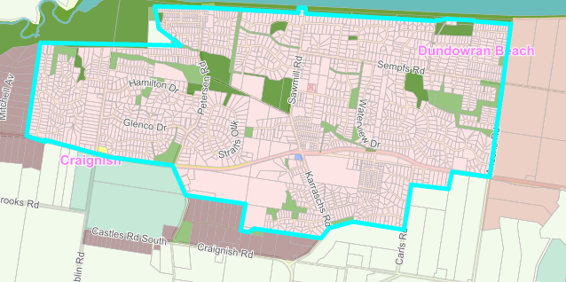

  - Kawungan/Urangan/Wondunna
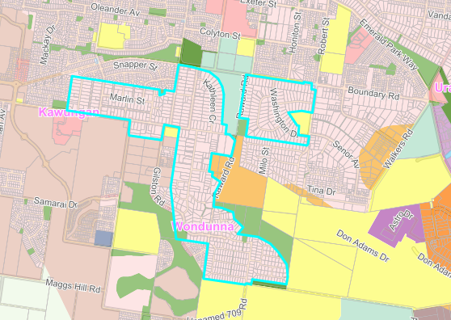

  - Toogoom
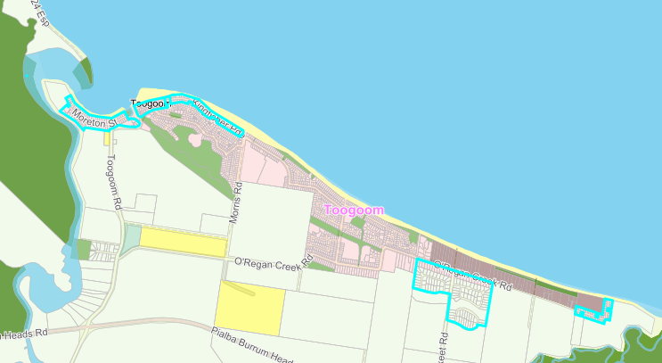

            - Rural villages

- A degree of reticulated sewer may already be available to service portions of the town with potential to connect to sewer in certain locations.
- The majority of lots have already been developed to capacity
- There may be a number of lots which are large enough to further subdivide but Council may not be planning to extend reticulated sewerage to them in the foreseeable future.
- There may be less capacity for additional development that would make connecting reticulated sewerage a viable option.
- There is no strategic intent to connect to reticulated sewerage in these some of these areas during the life of this planning scheme.
- No reticulated sewerage is currently available/extensive infrastructure is required to service the following suburbs –
- Aldershot
- Bauple
- Broweena
- Burrum Town
- Glenwood
- Gundiah
- Owanyilla
- Tiaro
- Tinana South
- Tuan Forest
- Walkers Point

- No reticulated sewerage is currently available in portions of the following suburbs, as identified below –

- Howard
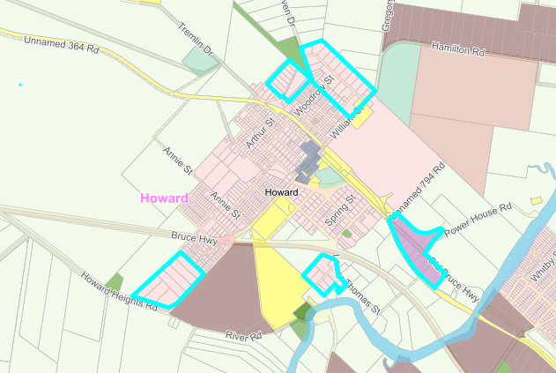

- Torbanlea
- A degree of reticulated sewer is already available to service portions of the town
- Subject to further Council decisions, there is potential for the area to connect to reticulated sewerage in the future.
- No spare capacity in the treatment plant without upgrades.

            - Coastal townships

- The locality, lack of lots, constraints (flood and coastal hazards), distance from the closest reticulated sewerage infrastructure and other constraints make extending sewer to the area an unviable option.
- There is no strategic intent to connect to reticulated sewerage in these areas during the life of this planning scheme.
- Retrofitting sewerage to existing aeas is difficulat, expensive and usually results are less than optimal.
- No reticulated sewerage is currently available in the following suburbs –
- Boonooroo/Tuan
- Fraser Island
- Maroom
- Poona
- River Heads
- Tinnanbar

Land Application areas are also known as Effluent Disposal Areas or EDAs.

