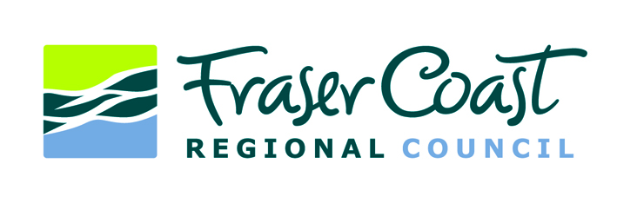MEDIA RELEASE
28 August 2024

Craignish park and Eli Waters waterbody named
A park on the corner of Pialba-Burrum Heads Road and Petersen Road in Craignish will be officially named ‘Craignish Park’ and a waterbody in Eli Waters will be officially named ‘Lake Eli’.
At its meeting today, Fraser Coast Regional Council endorsed the two naming recommendations, which followed community consultation in recent months.
Cr Michelle Govers said the park on the corner of Pialba-Burrum Heads Road and Petersen Road in Craignish features a playground, basketball court, walkways, BBQ facilities and an off-leash area where small dogs can be kept separate from big dogs.
“Council conducted community engagement throughout April and May and received over a hundred submissions with Craignish Park the most popular choice for a name,” she said.
“Petersen Park – in reference to the road and location of the park – was a close second, but this was not considered because there is an existing park with the same name in Dundowran.”
Cr Lachlan Cosgrove said the Neighbourhood Watch Eli Waters Hervey Bay 11 group had raised with him their desire for the waterbody that fronts Currawong Court, Bushlark Avenue, Spoonbill Way and Kestral Court to be named.
“Council consulted with nearby residents throughout July and received various suggestions,” he said.
“Ultimately, we have decided to name the waterbody ‘Lake Eli’, which is the name that received the largest amount of support during the recent consultation process.
“Naming this waterbody will help people easily recognise the area, support Neighbourhood Watch activities and better identify locations when interacting with Council and Emergency Services.”
For more information on Council’s Parks and Reserves Naming Policy, visit https://www.frasercoast.qld.gov.au/downloads/file/5008/parks-and-reserves-naming-council-policy

ENDS

